1- Uncheck or check show sales price or show cost price group to show/hide

product price for admin and user (Photo 1)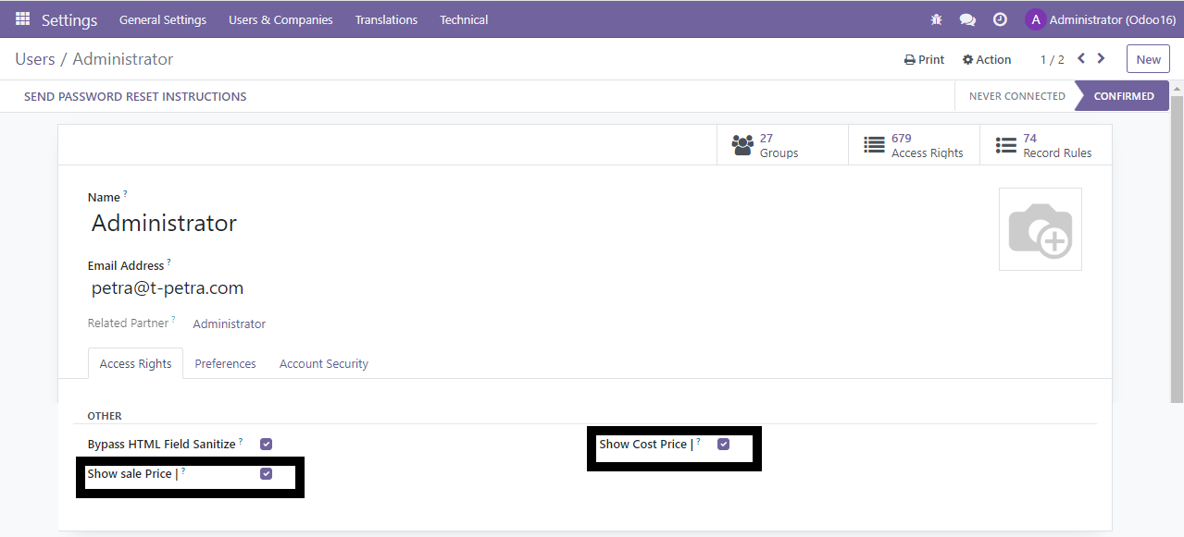

2- Show Sale price in kanban view (Photo 2)

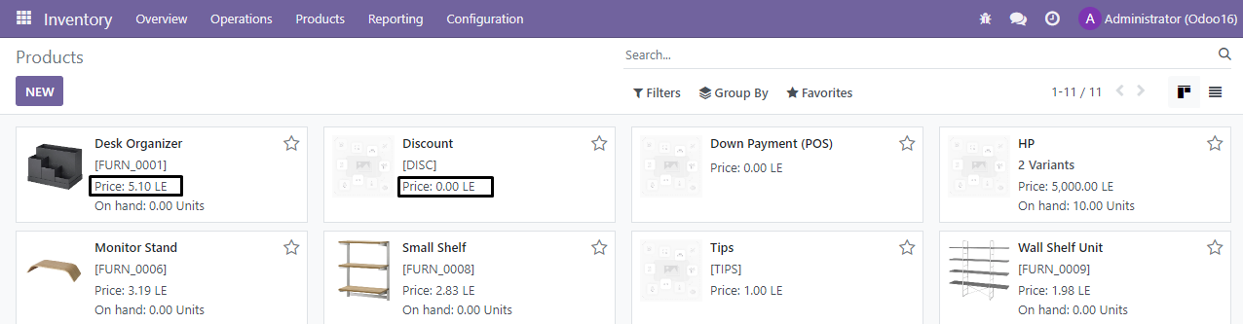

3-Hide Sale price in kanban view (Photo 3)

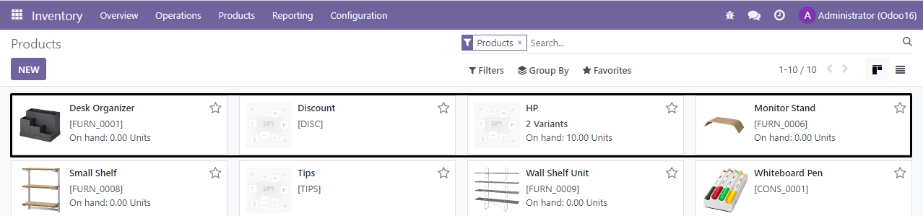

4-Show sales price and cost price in tree view (Photo4)

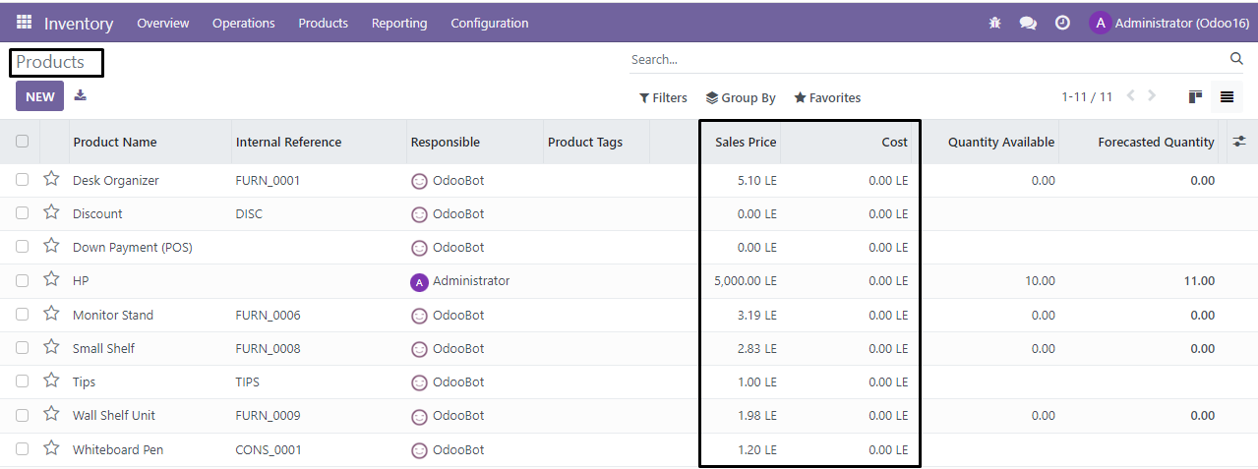

5- Hide sales price and cost price in tree view (Photo 5)

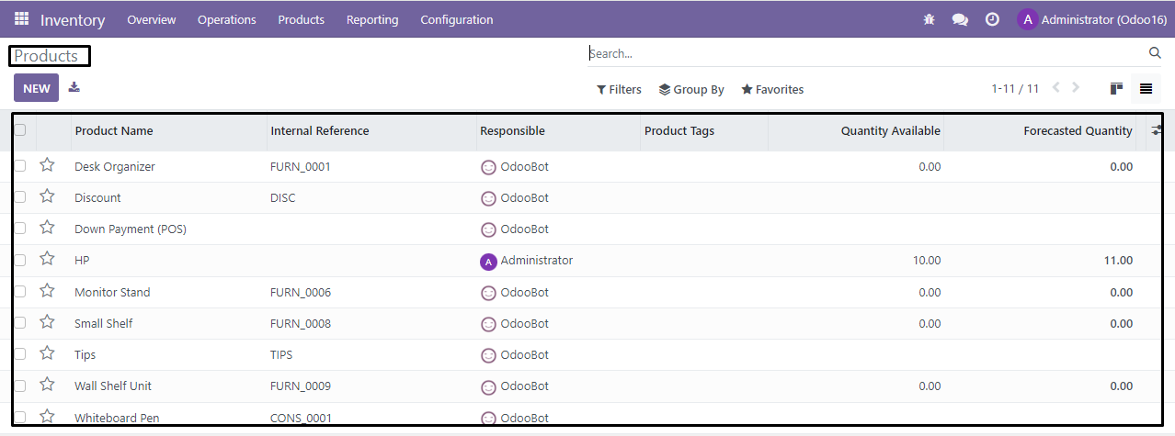

6-Show sales price and cost price in form view (Photo 6)

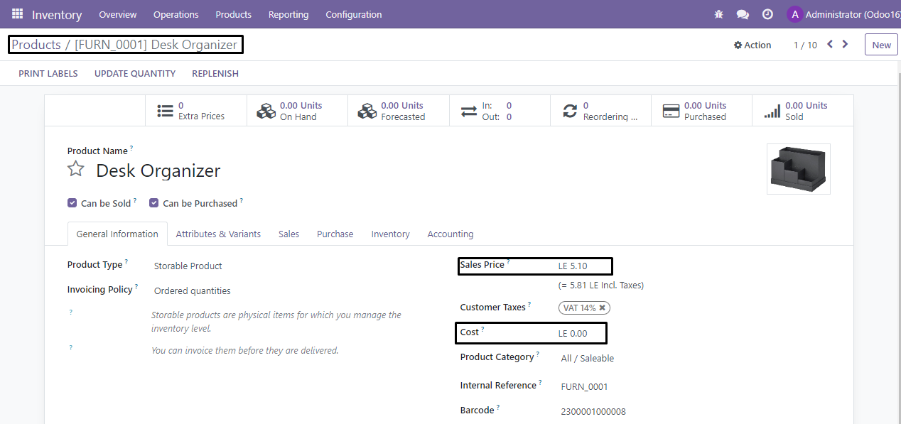

7-Hide sales price and cost price in form view (Photo 7)

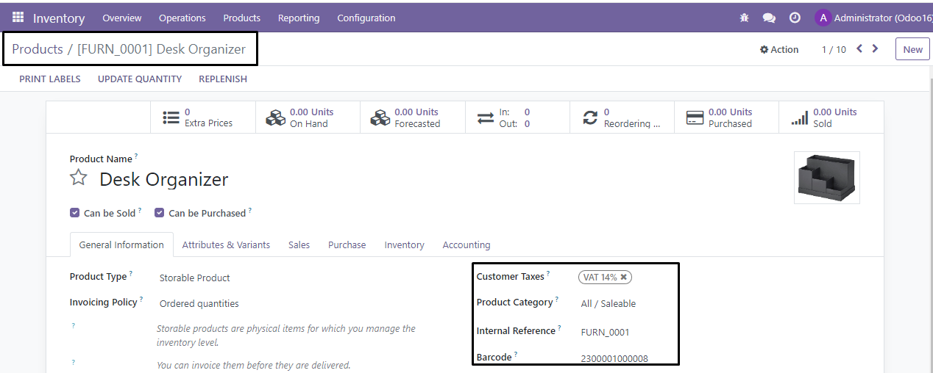

8-Show sales price and cost price in a tree view in product variants (Photo 8)

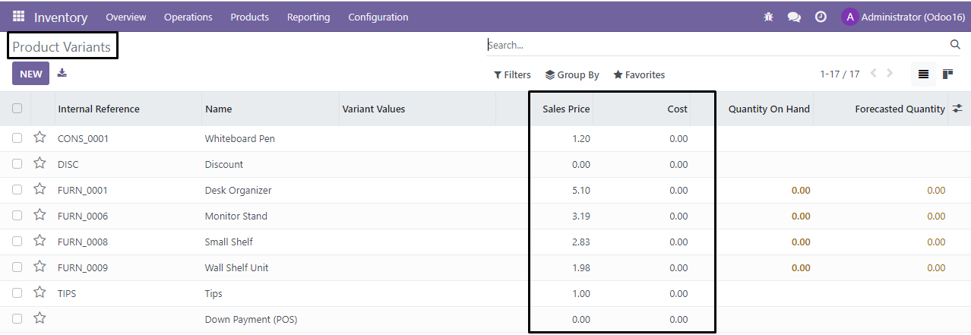

9- Hide sales price and cost price in a tree view in product variants (Photo 9)

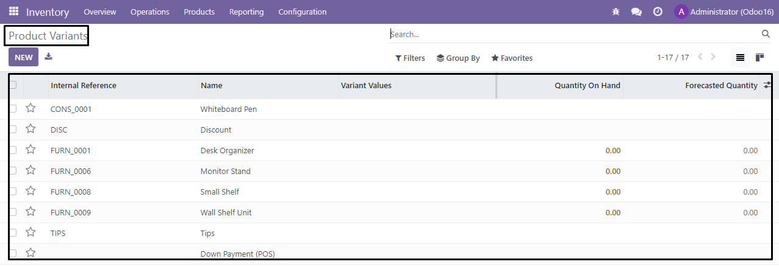

10-Show sales price in kanban view in product variants (Photo 10)

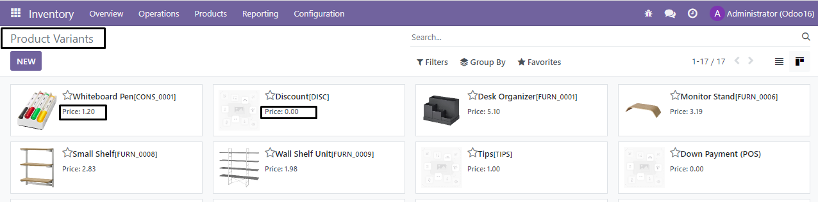

11-Hide sales price in kanban view in product variants (Photo 11)

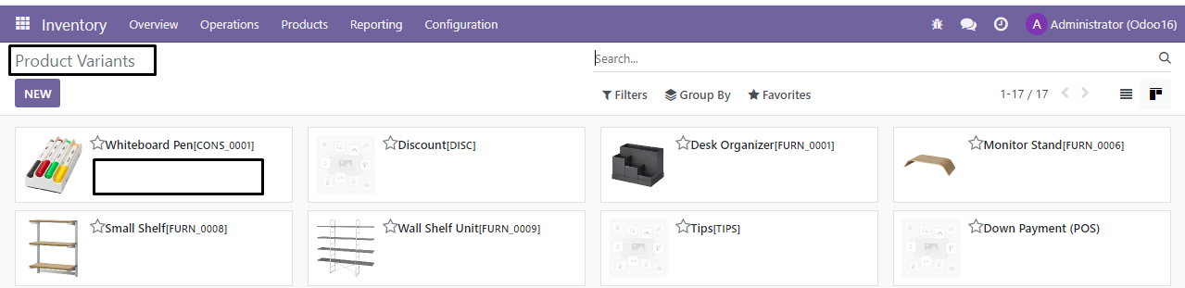

12-Show product price in the purchase form view. (Photo 12)

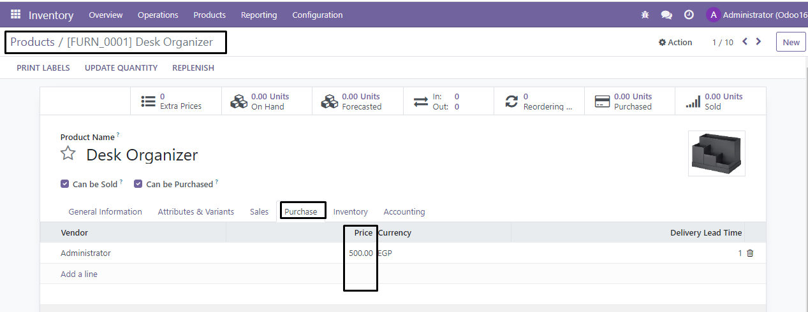

13-Hide the product price in the purchase form view. (Photo 13) 